History of the Danish Paper Doll by Dorte Meiling Nielsen

In 1999 an interesting book was published in Denmark. For the first time the history of the Danish paper doll was written. The authors are Birgitte Glob and Mette Winge, and the title of the book is: ”Pigedrømme” (”Girls Dreams”). Unfortunately the book is not published in English, but the many lovely photos representing paper dolls from 150 years, can be delightful to look at, and they tell their own story.

I have in this article tried to tell the very brief version of the Danish paper doll, based on the book.
I have illustrated it with paper dolls from my own collection.

The first paper dolls

Paper dolls appear in Denmark rather early in the 19th century.

In Danish museums you can find examples of handmade paperdolls from the first half of the 19th century. Even the famous poet Hans Christian Andersen has made a paper doll with a few gowns.

From the same period you find some wonderful handcoloured paper dolls of famous persons from the theatre - actors, singers and dancers. The Danish balletdancer, Lucille Grahn 1819 – 1907, is one of these. Just as today, celebrities were models.

But not until printing techniques and paper prices made it possible, the first regular sheets were published. It started in Germany in the 1830’s. These sheets quickly became popular in Denmark too, but after the wars between Denmark and Germany in the 1850’s and especially after the final Danish defeat in 1864, no things from Germany were acceptable.

A Danish publisher, Alfred Jacobsen, started in the 1870’s to print sheets with national motives, called ”Danish Pictures”. Among these sheets You also find paper dolls with national costumes and families, illustrating everyday life. These sheets became very popular, and they are still being reprinted.
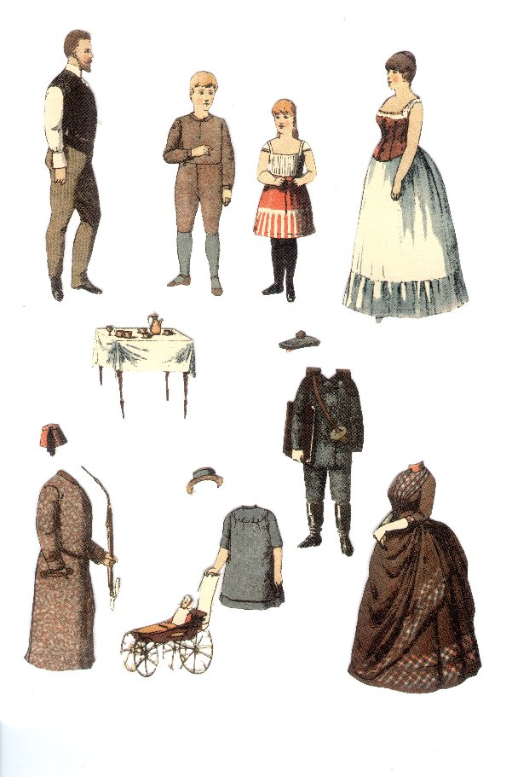
Ill.: ”Figurer til påklædning” (”Figures for dressing”) by Carsten Ravn, published by Alfred Jacobsen, 1888 (reprint)

Paper dolls in the early 20th century

From the beginning of the 20th century the weekly magazines regularly printed paper dolls. And soon the paper dolls also found their way to the advertising industry. They were used for selling all sorts of products during the 1920’s and 1930’s, both clothes and food.

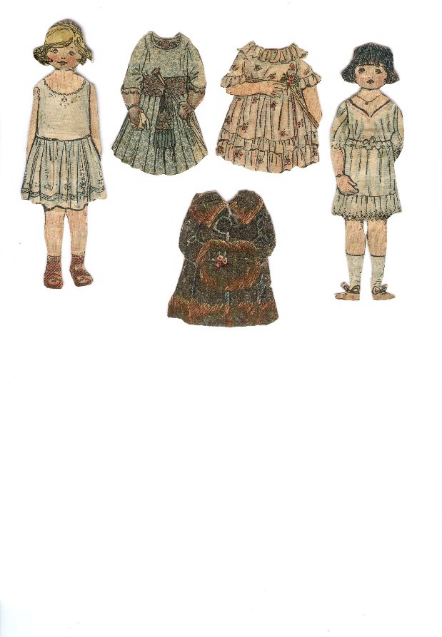
Ill.: Some of my grandmothers paperdolls from app. 1915 – 17, cut out from ”Familiejournalen”, a weekly magazine

”Store Marie”

The most famous advertising doll known in Denmark is ”Store Marie” (”Big Marie”). She was a very well drawn lady whose task was to sell bisquits (Marie Bisquits from the firm Jensen & Møller). She existed from 1940 – 1964, and was drawn by several different artists. A lot of her dresses are in red and white, just like the wrapping paper around the bisquits. She had a little sister, ”Lille Marie” (”Little Marie”), and later (when the rationing period on chocolate came to an end in 1952) a little black girl, called ”Sorte Marie” (”Black Marie”), also appeared. These dolls became extremely popular, little girls could even join a Marie club with its own magazine and badge. Store Marie was very well equipped. She had no less than 230 different dresses!

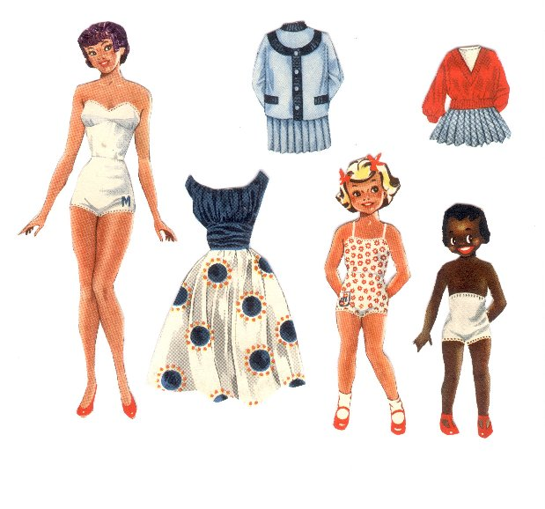

Ill.: The three Marie’s.

The original ”Big Marie” has blond hair and her coiffure is more like the one of ”Little Marie”, but as I had many ”Big Marie” pd’s, it was tempting to make them look different. Unfortunately I have changed the hair on all my Marie’s, so I cannot present the original!

Wartime paperdolls

During the war, and several years later, one of the very best Danish paper doll artists, Gerda Vinding, made a lot of lovely dolls. Smart, young ladies with jobs and lovely garments. International in their style. A new trend was born. Earlier the paper dolls primarily socialized the girls who played with them to a life in the family as the happy mother and wife. Now it was obvious that girls could also have a career of their own. Gerda Vindings models are nurses, gardeners and officegirls. Less realistic is that they all have large ball-room gowns, and generally they are equipped with a wardrobe which no normal woman in the years just after the war could match. But, no matter, there should also be room for the dreams!

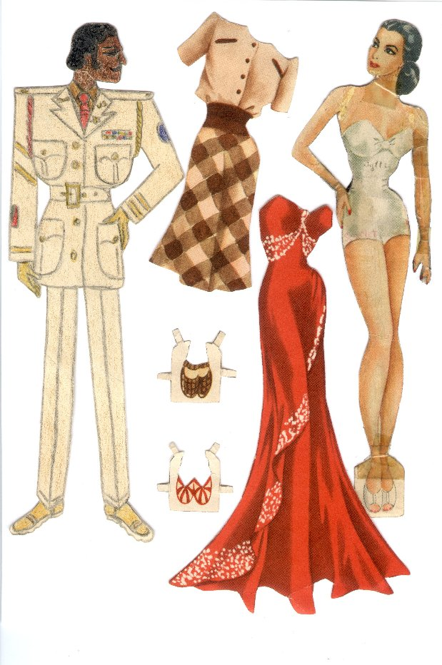
Ill.: One of Gerda Vinding’s lovely ladies. She – and ten other beauties - has belonged to my mother.
During the war my mother drawed American soldiers for the girls to go out with. One of these handsome guys is seen here.

Many good paper dolls derive from this period. It was a cheap toy, and this was a good thing in a time of shortage of everything. But most of the artists are anonymous; it was not ”true art” to draw paper dolls, so many did not even bother to sign their sheets.

The days of glory

The days of glory of the paper doll in Denmark is the period from the late 1940’s till the middle of the 1960’s.

In the weekly magazines paper dolls were often published. It was movie stars, both American and Danish. But when Elizabeth Taylor or Esther Williams appear as Danish dolls, they are more everyday-like than the similar American dolls. They were produced in the same style as their Danish colleagues, Lily Broberg and Birgitte Price.

The ”everyday look” can also be seen in the paper dolls of the three Danish princesses, Margrethe (the present queen), Benedicte and Annemarie. They are presented by Ebba Schultz in the 1940’s with clothes just like the ones worn by any Danish child.

In the 1950’s the advertising dolls had great days. They were used especially on breakfast products, like OTA and FOSKA oatmeal. From that period several very skilful artists are known. Christel created her own style with extremely thin and long-legged girls with alot of charm and spirit. They became ideals for a whole generation of teenage girls. Many of the artists of that period were also known as book illustrators.

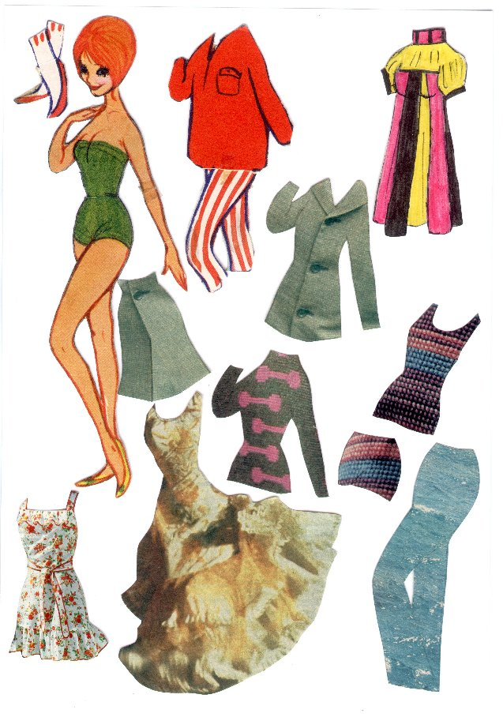
Ill.: A paperdoll made by Christel.
You see one original dress, one drawn by me around 1967 (a miniskirt in Baby doll style) and several dresses I have cut out from magazines. I could use everything to make clothes of, for instance you see in the corner down right, a pair of trousers made of water!

Is the paper doll dead?

In the late 1960’s the era of the paper doll is coming to an end, and by the end of the 1970’s the book declares the paper doll in Denmark for dead. The general attitude in society, and especially the womens liberation movement with its critical attitude to fashion and beauty and especially to the female role as sex object, are of course crucial factors. Add hereto the entrance of Barbie on the scene, and you have another explanation. The Barbie doll is, in a way, the ultimate paper doll – three dimensional and with alot of the same qualities.

The authors contradict themselves a little when they declare the paper doll dead, as they point out in the start of the book, the interest for collecting paper dolls is increasing in Denmark in these years. And who knows – perhaps we are standing in front of a renaissance? I would surely like to contribute to a revival.
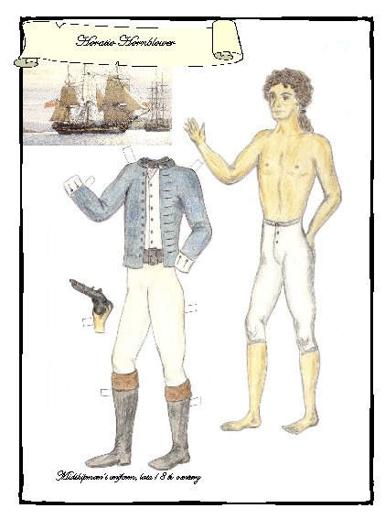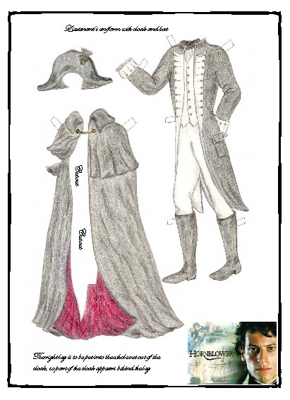
Ill.: I was inspired by the TV series, based on a novel by C.S. Forester, about the young Hornblower and his career in the British Navy in the late 18th century, to make this paperdoll last summer.
Birgitte Glob & Mette Winge: Pigedrømme, Samleren, 1999

